EMERGENCY MANAGEMENT PLAN

TEACHERS AND LEADERS MUST FAMILIARISE THEMSELVES WITH THIS INFORMATION
- HOW TO CONTACT THE MANAGER

- EMERGENCY PHONE NUMBERS & CAMP LOCATION

- APPROACH TO BE TAKEN IN AN EMERGENCY
(VARIFY > NOTIFY > ASSESS > ACT)

- RESPONSE PLANS TO POSSIBLE SITUATIONS
- BUSHFIRE AND TOTAL FIRE BAN POLICY (TFBP) PAGE 14 TO 20

- EMERGENCY ASSEMBLY AREAS & MAPS

COASTAL FOREST LODGE DOES NOT GUATANTEE THAT CAMP STAFF WILL BE AVAILABLE & ONSITE AT ALL TIMES. IF THE HEAD TEACHER/LEADER IS UNABLE TO CONTACT THE MANAGER AS OUTLINED, THEN THEY SHOULD ASSUME THE LEADERSHIP ROLE AS DESCRIBED BELOW AND WHERE POSSIBLE CONTINUE TO TRY AND CONTACT THE MANAGER.

Introduction:
This booklet outlines a range of preventive measures to avoid or minimise emergencies and how to handle such a situation if it were to occur.

CFL is an owner operated campsite. A manager lives onsite and is not always present when the campsite is occupied. The managers can be contact via mobile phone if they are offsite. Their mobile phone numbers are located around the camp, in this booklet and in the Teacher/Leader Information Booklet. There is no guarantee the manager will always be available and onsite .

Most accidents, injury and illness situations are not emergencies and are treated as routine.

CFL does NOT accept responsibility for first aid (or follow-up treatment) in the event of an accident, injury or illness to a camper – this is the responsibility of the group and their designated first aid person. All groups are required to bring their own first aid kits (including a mobile kit) to suit the needs, size and activities being undertaken by the visiting group. They must also bring a vehicle and at least one working mobile phone (Telstra). These items must always be accessible for emergency use.

BYO ALL FIRST AID KITS. BYO VEHICLE FOR EMERGENCY TRANSPORT. BYO TELSTRA MOBILE PHONE.

CFL endeavors to provide correct information if medical, ambulance or other assistance is required and an area for an ill or injured camper if needed. CFL does not transport participants. However, if requested to assist in taking an injured participant to medical aid in the event of an injury, then the following applies:

- At least one other group leader (adult) must accompany the injured person.
- The vehicle used is comprehensively insured and registered.
- The driver is licensed to drive the vehicle.
- A portable communication device e.g. mobile phone is taken on the trip.

Emergency contact numbers are displayed throughout the campsite: in the teachers / leaders meeting room thus staff room, all cabins, office, kitchen, recreational room and in the Teachers/Leaders Information Booklets (guests must print these before arrival).

Any incident / illness must be reported to the camp manager and is monitored closely. Where appropriate the manager will issue specific instructions to ensure the safety and wellbeing of campers. Where medical or other assistance is sought an Incident Report Sheet must be filled out and given to the camp manager. An Incident Report Sheet is only completed and forwarded to the insurance company if the injury is very serious or if there is a possibility of future litigation.

- HOW TO CONTACT THE MANAGERS

MANAGERS MOBILES
AVAILABLE 24/7

Iona Roberts: 0421 049 754

Allan Roberts: 0412 560 452

- EMERGENCY PHONE NUMBERS
EMERGENCY PHONE NUMBERS
DIAL 000
Fire, Police, Ambulance & S.E.S
At least one teacher / leader must have access to a MOBILE PHONE (TELSTRA) & VEHCILE AT ALL TIMES
Doctor:
Surfcoast Medical Centre: Anglesea: (03) 4215 6700
McMillan St ANGLESEA, VIC, 3230

Surfcoast Medical Centre: Torquay: (03) 4215 7900
Surfcoast Medical Centre, 100 Surf Coast Hwy, Torquay VIC 3228
Hospital: Geelong: (03) 4215 0000
Geelong Hospital Emergency Department, 1/75 Bellerine St, Geelong, VIC 3220
Chemist: Anglesea: (03) 5263 1540
93 Great Ocean Rd, Anglesea VIC 3230
Dentist: Torquay: (03) 5261 2240
110 Geelong Rd, Torquay VIC 3228
Police Station: Anglesea: (03) 5263 3468
55 Great Ocean Rd Anglesea
POISON INFORMATION: 13 11 26

Location Description:
“Coastal Forest Lodge”
Corner Forest and Gundrys Roads, Bellbrae VIC 3228.
*ENTRANCE: FOREST ROAD 2kms from the Great Ocean Road roundabout
6km before Anglesea
Country Vic Melway Map 296 G1
DIAL 000
Fire, Police, Ambulance & S.E.S
MELBOURNE TO CFL:

ENTER CAMP OFF FOREST ROAD (Bellbrae VIC 3228) - NOT GUNDRY’S ROAD!!
1. Go over the West Gate Bridge.
2. Continue onto the Princes Freeway M1.

3. Stay on the Princes Freeway M1 (Geelong bypass) until the very end. Follow the signs to Anglesea Rd (C134). Take the exit towards Anglesea Rd/C134. Stay on the C134 and go through Freshwater Creek (head straight through any roundabouts).
4. When you get to the end of the C134 at the top of a hill, there is a large roundabout - Torquay left and Anglesea right.
5. Head RIGHT to Anglesea - this is the start of the Great Ocean Road / B100. (IGNORE the Gundry’s Road turnoff!!!)
6. Stay on the Great Ocean Road until you reach a new roundabout (just past the new Great Ocean Road Chocolaterie, located on the right). Turn RIGHT at this roundabout, there is a large blue sign pointing RIGHT to FOREST ROAD. It reads Coastal Forest Lodge 2km. This is FOREST ROAD (also road to Winchelsea 32km). Turn RIGHT down Forest Road. Drive slowly - kangaroos will be active and crossing the road.
THE CAMP ENTRANCE is 2km on the RIGHT on FOREST ROAD!!
7. If you reach Anglesea, you’ve gone too far. Forest Road is 6km BEFORE Anglesea.
8. If travelling from Angelsea there is no signage for the lodge on The Great Ocean Road, just a big sign that reads Winchelsea 32km.
1.5 hrs from Melbourne
Please drive slowly down Forest Road and watch out for kangaroos crossing. They will damage your car.

- APPROACH TO BE TAKEN IN AN EMERGENCY

- VERIFY: Verify the report

- Confirm with other campers, with emergency services or other reliable people the accuracy of information about the emergency.

- NOTIFY: Notify the emergency services and CFL staff

By the quickest possible means, immediately notify:
- The emergency services
- CFL staff

- ASSESS: Assess the danger posed by the emergency

- Use all your senses to build a picture which tells you what is happening and use that information to help decide on a course of action.
- Use verbal information
- Observe what is happening to decide:
. Has the danger passed?
. Is the danger increasing or decreasing?
. Is the danger coming closer or moving further away?
. Is the weather or tertian affecting its progress?
- Decide how much time exists to take alternative actions.

- ACT: Take action based on the assessment of danger

- Ensure that injured campers are not exposed to further injury or danger.
- Contain the emergency if safe to do so.
- Move people way from the danger area by the safest means, if necessary, move campers indoors, to one end of the building, to the furthermost part of the campsite, or to a site well away from the campsite is time permits.
- Refer to any specific procedures within the CFL Emergency Management Plan located in the Meeting Room.
EMERGENCY ASSEMBLY AREAS:

- CAR PARK

- BASKETBALL COURT

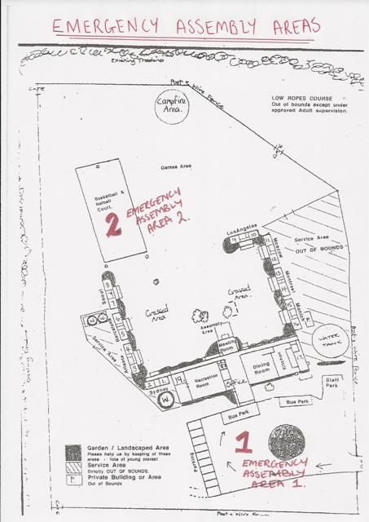

- RESPONSE PLAN TO POSSIBLE SITUATIONS
FIRE
Fire is an ever-present risk in and around a campsite. During the months from December to April the risk in the Anglesea area increases, therefore a careful, informative and sensible approach to this situation is required by all.
There are three situations which may occur:
- A fire in a building or camp equipment.
- A fire on the camp property but away from the buildings.
- A fire approaching the campsite outside the property.

To assist in the safety of all, please familiarise yourself with this plan and observe some simple fire safety rules:
CFL FIRE SAFETY RULES
- CHECK WITH THE MANAGER BEFORE LIGHTING ANY FIRES OR SMOKING (NO SMOKING ON THE DECKING @ ANYTIME). Smoking is only permitted on the concrete slabs. Butts disposed of in tins available.
- FAMILIARISE & FOLLOW THE CAMPS ‘TOTAL FIRE BAN POLICY’ (page 14).
- EXPLAIN TO YOUR GROUP POSSIBLE FIRE SITUATIONS AROUND THE CAMPSITE & CLEAR EMERGENCY PROCEDURES.
- REPORT ANY SMOKE OR CONCERNS TO MANAGER IMMEDIATELY.
- AFTER CAMPFIRES & ‘COOK OUTS’ IN THE DESIGNATED AREA ENSURE THE CAMP FIRE IS COMPLETELY OUT, USE WATER PROVIDED IN BIG GREEN BIN.

ASSEMBLY AREAS:

- CAR PARK

- BASKETBALL
COURT

FIRE
Q) What will the camp manager do?
1. Sound the campsite EMERGENCY SIGNAL (PORTABLE MARINE HORN - LOCATED BEHIND THE FEEDBACK BOX IN THE MEETING ROOM / STAFF ROOM) located in the meeting room / staff room.
2. Contact Emergency Services 000
3. A Teachers / Group Leaders to check lists and inform manager if anyone is unaccounted for.
4. Check all buildings and toilets.
5. Monitor situation – consult with CFA, Police and SES.
6. Co-opt the assistance of Teachers / Leaders if necessary.
7. Evacuate at the direction of the police / emergency services to a safety area.

IF THE CAMP MANAGER IS NOT ON SITE THE TEACHER / LEADERS IN CHARGE OF THE GROUP MUST ASSUME THE ABOVE RESPONSIBILITIES.

Q) What the Teachers / Leaders should do?
1. On hearing the emergency signal direct / escort campers to the closest assembly area:
- Car park - Basketball Court
2. The Head Teacher / Leader should collect camper lists and medical forms and check the roll. Inform the manager IMMEDIATELY if anyone is unaccounted for.
3 Help maintain calm atmosphere, organize quiet activities and stay with campers until instructed otherwise.
4. Carry out any instructions from the manager and assist with evacuation if directed to do so by police. Campers should not attempt to extinguish fires.

FIRE – BUILDING OR AROUND CAMP

- Notify Camp Manager
Iona - 0421 049 754, Pete - 0401042676 or Allan - 0412 560 452

- Manager – verify report either directly or via a responsible adult source. Make a decision about appropriate action.

- Assess situation realistically. The manager will sound EMERGENCY SIGNAL (PORTABLE MARINE HORN - LOCATED BEHIND THE FEEDBACK BOX IN THE MEETING ROOM / STAFF ROOM) located in the meeting room and demonstrated in the safety briefing) if required. All campers MUST go to an emergency assembly area:

1. Car Park 2. Basketball Court

- Check everyone is accounted for and contact CFA and Police (call: 000). This may be done before issuing the emergency signal.

- Teachers / Leaders supervise campers until the emergency is resolved.

- If evacuation is required, follow the bushfire plan on the next page. It will be at the direction of CFA & police. The camp Manager will direct campers to the safest campsite location until emergency services / transport arrives.

- Everyone remains calm.

BUSHFIRE
*** GUESTS ARE ENTERING A BUSHFIRE AREA – THEY ENTER AT THEIR OWN RISK ***

*** DOWNLOAD THE VIC EMERGENCY APP - ENTER BELLBRAE & ANGLESEA WATCH ZONE ***

*** GUESTS MUST HAVE TELSTRA COVERAGE ***

***LEAVE EARLY***

- CFL Total Fire Ban Policy (TFBP)
- 1 TFB Day = vacate campsite and Anglesea area. Travel offsite to activities in Torquay or Geelong or travel home.
- 2 + TFB Days (consecutive) = cancel camp and reschedule for another date.

- Report any sign of bushfire immediately to CFA, police & camp manager. The manager will verify report with local fire authorities and check for any potential dangers.

- Appropriate action: managers will consult with teachers / leaders, except in the case of immediate danger where the manager implements immediate emergency procedures.
No Danger: Inform campers all is okay but ask them to be alert to any changes and remain vigilant.

No Immediate Danger but possibility exists: Consult with local authorities regarding the possibility of evacuation and other precautions / steps to be taken. Recommend to groups to LEAVE EARLY and evacuate the campsite well in advance.

COLES COACHES - PH: 5243 8772

***(SELF CATER GROUPS MUST SUPPLY THEIR OWN EMERGENCY EVACUATION TRANSPORT)***

Danger Imminent: Implement emergency procedures: signal siren, assemble in emergency areas, check-off / role-call and evacuate premises in a calm and organised manner. Police and CFA will be closely involved. Campsite staff will follow police directions.

- Assembly Areas: 1. CAR PARK 2. BASKETBALL COURT
These two areas are clearly defined during the campsite safety briefing and are identified by a green sign with white writing reading ‘Emergency Assembly Area’.

- Safe Assembly Area Procedures:
On hearing the EMERGENCY SIGNAL (PORTABLE MARINE HORN - LOCATED BEHIND THE FEEDBACK BOX IN THE MEETING ROOM / STAFF ROOM) demonstrated in safety briefing) all campers must proceed to the closest assembly point. A teacher/leader must collect camper rolls and medical forms and check to make sure everyone is present. They must then await further instructions.

- Evacuation Procedures:
Evacuation from the site will be done under the direction of CFA or police. The campsite manager will liaise with the CFA and police and take advice as to timing, procedures, routes and destination points to suit the set of circumstances. If time permits, the teacher / leaders will make sure that all campers have appropriate clothing and carry a woolen blanket, mask and bottle of water, they should NOT collect personal property. They must ensure that all campers are always accounted for. Evacuation will normally be to the closest most appropriate Emergency Assembly Area as determined by authorities i.e. CFA and police.

***(SELF CATER GROUPS MUST SUPPLY THEIR OWN EMERGENCY EVACUATION TRANSPORT)***

- Evacuation Alternatives:
CFL has two alternative evacuation routes:

- Forest Rd (main camp entrance).

- Gundry’s Rd (private camp managers driveway, dirt road, limited phone reception). This gate may look paddocked but it NEVER is, get out and try the lock, it will be open!

COLES COACHES - PH: 5243 8772

***(SELF CATER GROUPS MUST SUPPLY THEIR OWN EMERGENCY EVACUATION TRANSPORT) ***
If evacuation is not an option, then campers will be assembled and taken to the safest clear onsite area by the manager.
Campsite staff should: turn off gas, check all rooms, close windows/doors, fill sinks and troughs with water, and fill buckets, start-up water pumps.
Visiting staff should: ensure all campers are accounted for, stay alert and listen, remain calm, ensure campers are comfortable, inform the campers calmly about what is happening, reassure campers, keep campers occupied with activities where possible.
- STAY CALM -
Once the front has passed staff should check for spot fires and extinguish them. Check for small outbreaks within the building and extinguish them.
- Notification:
As soon as possible notify authorities, police, CFA, SES, school, parents and families of current situation. Make appropriate arrangements for campers.

***(SELF CATER GROUPS MUST SUPPLY THEIR OWN EMERGENCY VACUATION TRANSPORT) ***
*** GUESTS ARE ENTERING A BUSHFIRE AREA – THEY ENTER AT THEIR OWN RISK ***

HIGH FIRE DANGER / TOTAL FIRE BAN :

*** GUESTS ARE ENTERING A BUSHFIRE AREA – THEY ENTER AT THEIR OWN RISK ***

- NO FIRES OF ANY SORT, NO SMOKING, NO MATCHES, NO LIGHTERS, ETC.

*** DOWNLOAD THE VIC EMERGENCY APP - ENTER BELLBRAE & ANGLESEA WATCH ZONE ***

*** GUESTS MUST HAVE TELSTRA COVERAGE ***

***LEAVE EARLY***

Total Fire Ban Policy (TFBP):
- 1 TFB Day = vacate campsite and Anglesea area. Travel offsite to activities in Torquay or Geelong or travel home. Return to camp when safe and approved by camp manager.
- 2 + TFB Days (consecutive) = cancel camp and re schedule for another date.

- The Manager will liaise with the CFA regarding camper’s safety & organise alternative transport for school groups/catered groups if need be. COLES COACHES - PH: 5243 8772
***(SELF CATER GROUPS MUST SUPPLY THEIR OWN EMERGENCY EVACUATION TRANSPORT) ***

- The Manager will inform visiting staff of total fire days or high fire risk days and will:

- Ensure a camp staff member is always on site.
- Check the groups program before the day arrives and offer safety advice & alternative suggestions.
- Implement the camps Total Fire Ban (TFB) Policy.
- Any safety restrictions put in place by the camp manager must be followed by everyone.
- Ensure firefighting equipment is accessible and operational.
- Organise emergency transport for school group evacuation, if required and safe to do so. COLES COACHES - PH: 5243 8772

***(SELF CATER GROUPS MUST SUPPLY THEIR OWN EMERGENCY EVACUATION TRANSPORT) ***

- This Emergency Management Plan is displayed in the Teachers Information Booklet, staff room, recreational room and dining room.

- Camp staff are aware of these safety procedures and will follow them if required.

*** DOWNLOAD THE VIC EMERGENCY APP - ENTER BELLBRAE & ANGLESEA WATCH ZONE ***

*** GUESTS MUST HAVE TELSTRA COVERAGE ***

***LEAVE EARLY***

SERIOUS INJURY OR BITE

- The Teacher / Leader in charge either gives or immediately arranges the first aid person to render assistance. Another person is sent to phone for assistance / ambulance. They must provide accurate information. Emergency phone numbers and exact campsite location are located around the campsite and in Teachers / Leaders Meeting Room. Also in their Information Booklet.

- Other campers are removed from the immediate area and supervised until the situation is resolved.

- All groups must bring at least a vehicle and mobile phone for emergency use. All groups are required to bring BYO adequate first aid kits and a trained first aid person or designated person who is responsible for illness / first aid of campers. Campsite staff are NOT RESPONSIBLE.

- The manager should be informed as soon as practical. If required, an Incident Report Sheet should be completed.

- A copy of this plan Emergency Management Plan is displayed in the Teachers/ Leaders Information Booklet and Meeting Room.

- Campsite staff are aware of these procedures.

MAJOR GAS LEAK

- Any sign of a gas leak (e.g. smell, sound) must be reported to the Manager ASAP.

- Camp manager will verify the leak by inspecting all possible sources such as appliance tanks, regulators, piping.

- If a leak is confirmed immediately SHUT OFF TANK SUPPLIES and shut off all appliances (stoves, heaters, hot water service, turn off all pilot lights and any other ignition sources.) The location of shut-off points are located on map

- Inform Teachers/ Leaders of the leak and course of action to be implemented.

- The Manager will contact a Plumber / Tradesman from the CFL Preferred Suppliers and Contactors list. If the leak appears to be a storage tank problem, then the Origin Gas Emergency Number will be called – this is displayed on the storage tank itself and also on the CFL Preferred Suppliers and Contactors list enclosed.

- If evacuation (either to a safe area around campsite or offsite) is required, the emergency signal will sound, and campers must gather at the designated assembly areas. The roll will be checked, and instructions given concerning activities and actions, until the affected area/s are considered safe.

- If any campers are ill the teacher / leader should seek appropriate medical assistance.

- These procedures are displayed in the staff room thus teachers / leaders meeting room. A copy is kept in the recreational room, dining room and office.

- Campsite staff is aware of these response plans. They know how to turn off the gas supply, where and how to eliminate ignition sources and how to contact relevant emergency persons. If any changes occur which may affect this plan, then the camp manager must inform camp staff and teachers / leaders.

LOST / MISSING CAMPER

- Teacher / Leader in charge must verify with other staff and campers that a camper is missing and should then inform the manager by the quickest possible means.

- Teacher / Leader should establish last seen location of camper, description including clothing and footwear and any special needs from Camper’s Medical Information Form.

- Manager should begin to record incident information including times of action, contact names and medical information.

- All campers should be gathered in a specific location and supervised by a staff member. If at night, then campers can be in bed with a leader to supervise. A roll must be marked in either situation to establish whereabouts of call campers.

- Manager should institute a search (using available staff) of all camp buildings and immediate campgrounds leaving a staff member at last seen location and office. If possible, a short drive outside camp should be done.

- If not found: - Manager should notify police.
- Teacher / Leader should notify Principal and Parent / Guardian or emergency contact.
- Try to verify with parent / contact the medical information and any previous incidents of going missing.
- Leave camp and managers phone number for return calls
(03) 5263 1300 Iona Roberts: 0421 049 754
Allan Roberts: 0412 560 452

- When police arrive take their advice as to further action or calling for extra assistance e.g. SES or CFA

- Media inquiries should be referred to Manager, Police or Principal.

- Manager should co-ordinate camp situation: monitor phone calls, supply maps and information as required, ensure Teachers / Leaders are supervising other campers, organise another check of buildings and grounds, monitor last seen location, take advice from Police as to whether Principal / contact should attend camp and have the Teacher / Leader phone principal at least every half hour.

- When missing camper is found Manager must inform all parties and document the incident in full.

ELECTRICITY FAILURE, WATER LOSS OR GAS LOSS

These problems are not considered emergencies bit routine incidents to be dealt with the Manager ASAP.

What to do?
A staff member or teacher/leader reports the problem to the Manager immediately who takes the appropriate actions to solve the situation immediately such action may be to contact a tradesman for assistance.

SUSPECTED COVID-19 CASE
What are the symptoms of COVID-19?
A coronavirus infection can cause mild to severe respiratory illness. The most common coronavirus (COVID-19) symptoms reported are:

Most common COVID-19 symptoms:
• Fever
• Breathing difficulties and breathlessness
• Cough
• Sore throat
• Runny nose
• Fatigue or tiredness

Less common symptoms:
• Aches and pains
• Sore throat
• Diarrhea
• Conjunctivitis
• Headache
• Loss of taste or smell
• A rash on skin, or discoloration of fingers or toes

What to do if you or someone at camp has any of the above symptoms:
- Inform the camp manager immediately on 0421049754 and group leader/s.

- Self-isolate immediately.

- If you develop a fever, cough, sore throat, tiredness, and shortness of breath, you should seek urgent medical care, immediately self-isolate, and inform the camp manager and group leader/s.

- The camp manager and your doctor will liaise with public health authorities and school.

- Seek immediate medical attention if you have serious symptoms. Always call before visiting your doctor or health facility.

- People with mild symptoms who are otherwise healthy should manage their symptoms at home after informing the camp manager and camp leader/s and must get tested. Do not stop off anywhere on the way home.

- On average it takes 5–6 days from when someone is infected with the virus for symptoms to show, however it can take up to 14 days.

- You must remain isolated in your home, or in a healthcare setting until public health authorities inform you it is safe for you to return to your usual activities.

- For more information about the transmission and symptoms of COVID-19, see https://www.health.gov.au/sites/default/files/documents/2020/04/coronavirus-COVID-19frequently-asked-questions_10.pdf

- Consider having a flu shot.

- EMERGENCY ASSEMBLY AREAS & SHUT-OFF POINTS. See maps below. 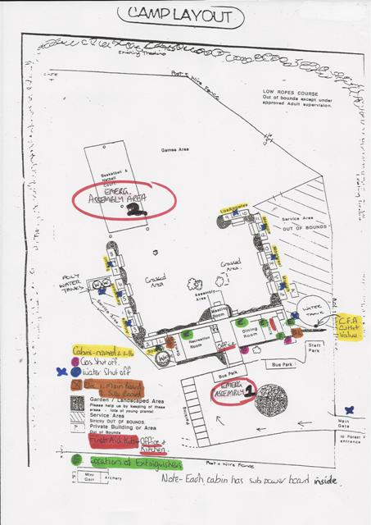
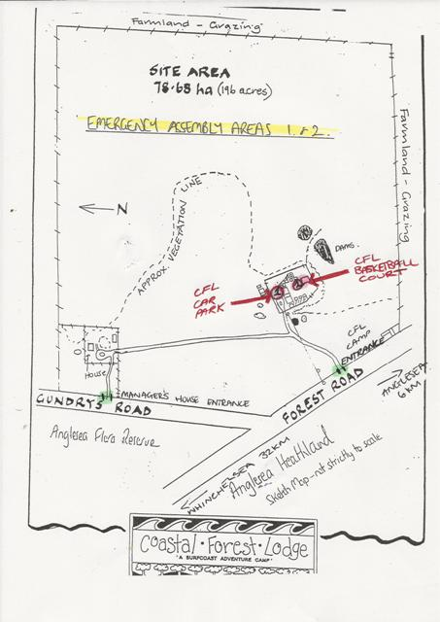
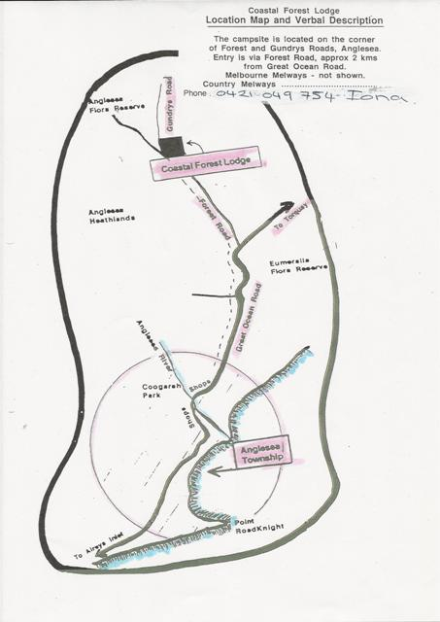
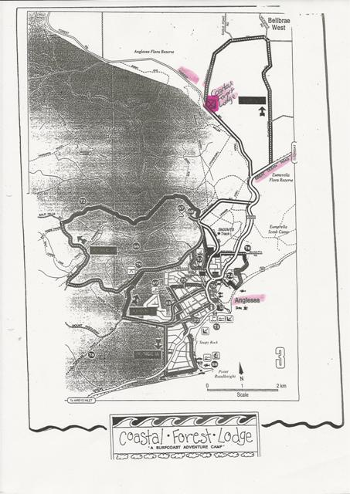

CFL PREFERRED SUPPLIERS & CONTRACTORS LIST 2019
TRADESMEN
Builder | Dale Roberts | 0427 431 026
Plumber | Danny Powel | 0418 329 513
Electrician | M & M Reed Electrical | 0430 308 603
Fridges | Bellarine & Westcoast Refridgeration | (03) 5244 0088
Glass | Anglesea Glazing (Will) | 0409 945 300
Water | Larcombe & Sons | 0407 350 716
Dishwasher | Tony Doolan | 0417 054 814
Bartletts Waste | Phil O’Brien | (03) 5248 7955  0407 339 188
Water Pumps | Webster Engineering –Geelong | 5243 5137
 | Davey Dyna Flow-HS 60&50 models | AH 5254 1300
Powercor | Emergency | 13 24 12
Origin  LPG GAS |  | 13 24 61  1800 808 526
Icon Sep Tech | Brendan | 0430046945
SUPPLIERS
Coles Coaches |  | David: 5243 8772  0429 944 968  Paul: 0409 020 068  Colac Depot: 5231 4656
Barwon Cleaning |  | P: 5221 2944
Coastal Locksmiths – Torquay |  | P: 5261 2822
RECREATION ACTIVITY SUPPLIERS AND CAMPS
Ecologic | Regina | P: 5263 1133
GoRats | Simon | P: 0417 576 973
Go Ride a Wave |  | P: 5263 2111
Ken Hooke- Bush Dance | Ken & Elly | P: 5568 7286
ACA | Steve | 1300 734 187  P: 9430 2950
INFORMATION
Dep. Environment Land Water Planning (DELWP) |  | P: 5233 5527  Icccol.log@icc.vic.gov.au
CFA - Region 7 HQ Office | Gerry Verdoon | 0418 542 829  P: 5277 1499
Parks Vic / DSE |  | Alcoa: 5263 4205  Lorne: 5289 4100

INCIDENT RESPONSE SHEETS – located in office.

