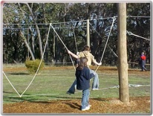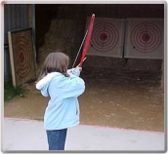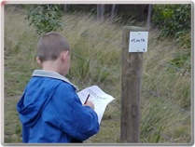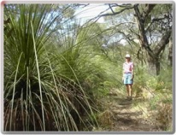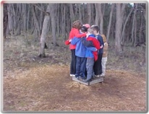

***CFL Onsite Activity Ideas***

* Coastal Forest Lodge has a terrific selection of teacher/leader lead onsite rotational activities to choose from.
* Onsite rotational activities are generally 1-hour rotations.
* These activities are run by school staff. All materials and equipment are supplied by CFL. A thorough safety briefing and instruction handouts are provided by CFL staff.
* Rotational group size: up to 15 people per group.
* Instruction handouts and safety briefings are provided by camp staff upon arrival.
* All equipment and materials required for onsite rotational activities are provided by CFL.
* Groups must provide their own first aid kits (including portable packs), asthma kits, Epipens, qualified personnel, etc. as per hire agreement.
* Covered nonslip shoes to be worn for all onsite activities (no thongs, sandals, etc.)

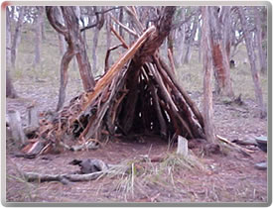

***ARCHERY***

Undercover area, fun, educational, safe (confined area) with two targets, straight forward to conduct after CFL safety briefing (assistance available), new equipment (securely stored), quick improvement by students after correct instruction, challenge/games can be introduced incorporating mathematics, individual and small group competitions can be introduced.

***LOW ROPES COURSE***

Eleven elements, challenging and fun, professionally built and maintained by Australian Ropes Course Builders. Safety briefings, helmets, and instructions provided - builds confidence, cooperation, self-esteem, teamwork and increases motor skills and coordination. Nonslip covered shoes to be worn. Each participant to have two active and appropriately sized spotters per person. The safety/rule notice board to be followed.

***EAGLES NEST WALK***

A beautiful bushwalk, easy to follow, guided walk with points of interest along the way, great to sketch & write about, lots of native wildlife, not to be missed! 30min to 60min.

***ORIENTEERING***

Challenging, fun, educational, easy to conduct (briefing provided), all set-up and ready to go, master sheets provided, students can work individually or in pairs, develops observations and map reading skills, variety of courses. Run within the fenced Alcove area.

***BUSHWALKS***

The Eagles Nest and Boundary Rider (night walk) on site and off site the National Heritage Heathland area across Forest Road (right opposite camp), and Flora Reserve across Gundrys Road. Hike to Anglesea / Coogoorah Park for a picnic lunch and activities at the beach i.e. SeaEarth Adventures, Ecologic or Go Ride a Wave. Receive a complimentary bus transfer per student back to camp at 4.15pm. CFL will also supply a guide to lead the walk.

***PHOTO TRAIL***

Challenging, fun, educational, easy to conduct/teach (briefing provided, all set and ready to go, master sheets provided, students can work individually or in pairs/small groups. Develops observational skills and helps students become familiar with new environments, enhances communication and teamwork. All ran with the fenced Alcove area.

[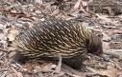](http://www.google.com.au/imgres?imgurl=http://www.hedonistichiking.com.au/images/Echidna.jpg&imgrefurl=http://www.hedonistichiking.com.au/high_country.html&usg=__7UZalzTUQuXEGBSA3WLXF05avmQ=&h=286&w=448&sz=53&hl=en&start=1&zoom=1&um=1&itbs=1&tbnid=heMyw-fnBrhXfM:&tbnh=81&tbnw=127&prev=/images?q=victorian+echidna&um=1&hl=en&rlz=1R2DBAU_en&tbs=isch:1)***INITIATIVE ACTIVITIES***

Challenging small group problem solving activities:

1. *Spiders Web*
2. *Magic Hoop*
3. *All Aboard*
4. *Pole Shuffle*
5. *Nitro Crossing*

Safety briefings and a laminated instruction booklet provided. Develops confidence, cooperation, coordination, lateral thinking, and teamwork skills.

***ART & CRAFT***

Use natural material from the camp environment or a combination of natural and artificial materials (from school) to make: Nutty Creatures, Rock Monsters, Mobiles, Collages, Leaf Bookmarks, Drawings and sketches, Aboriginal dot painting, Kite making. ***If desired schools need to supply art/craft materials required.***

***BUSH COOKOUT***

This includes lighting a fire and damper preparation and cooking. This is a great afternoon or rotational activity. Produce is provided by arrangement with manager. Very popular and yummy! Helps develop fire safety awareness, environmental awareness and cooperative skills. Students must collect their own wood and cook their own damper and eat it too! GF flour and separate bowls/utensils available for people with dietary requirements.

***\* AVAILABLE SUBJECT TO FIRE RESTRICTIONS AND WEATHER CONDITIONS\****

***MINI GOLF***

Nine-hole undercover course that is challenging, colorful and enjoyable. Equipment is provided for nine players at one time. Rules and score sheet are provided. This is a relaxing rotational activity. Popular with both students and teachers. Award a certificate to the CFL mini golf champ from your group.

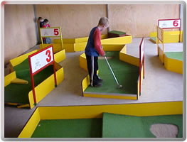

***BUSH SHELTER BUILDING***

Students construct bush shelters using natural materials in the designated area. This is an enjoyable and challenging activity which promotes creativity and some common sense to make it stand and provide adequate shelter. Helps develop teamwork, cooperation, and communication skills. It promotes awareness of the natural environment – no damage/destruction policy. Shelters **must be constructed in the designated area only and approved by an adult before entry**. Set the water test: See how waterproof your shelter is?



***YABBYING***

This activity is available in the warmer months when the crustations are active. Information sheets and safety briefings are available onsite. Equipment is available by arrangement. This is a fun activity that encourages quietness, patience and some casting skills.

***PETTING PADDOCK***

We have some friendly farm animals that are eager to meet our guests. This activity is run by CFL staff. **No person is to enter this paddock without permission or CFL staff present.** This is a very fun and exciting activity. Come and meet Arlo our super cute and friendly alpaca, and Lucky, Tiny, Ilona, Milly, Molly and Holly our pet sheep along with Buck, Tank, Puller and Ricky our very happy and friendly horses and donkeys. We also have plenty of hungry angus cattle waiting to be fed.

***POST CARD WRITING***

Students can write postcards on the first evening to send home to their families. CFL will post them. Hopefully the cards reach home before the students do. This is a fun exercise to enhance communication and writing skills and a perfect wet weather activity.

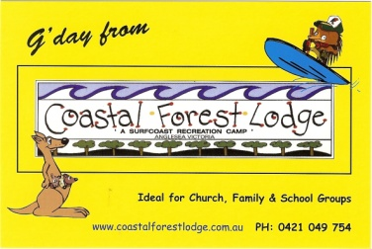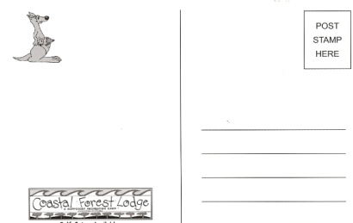

***AT NIGHT***

Inside & Out

***POSTCARD WRITING:*** (postcards are supplied by CFL), night walk, tabloid sports, spotlight tiggy, table tennis, air hockey, concert/red faces, ***HIGHLY RECOMMEND Ken Hooke Bush Dance $8.80pp (ask Iona to book)***, disco (disco ball available), movies (DVDs, projector and screen provided by CFL), stargazing – super amazing on a clear night, campfire and marshmallows, or hireEcologic for an engaging range of educational night activities onsite such as Possum Prowl.

***WET WEATHER***

Tabloid sports, concert rehearsals, camp poster, diaries and postcard writing, art & craft, dancing, aerobics, word games & charades, video/DVD (screen and projector provided by CFL), mini golf, archery, table tennis & air hockey*.*

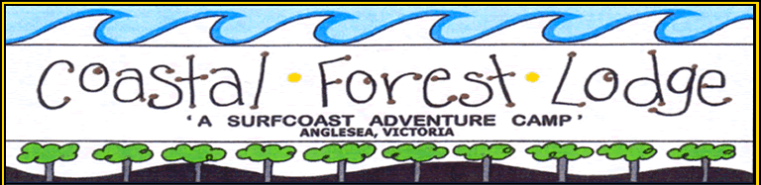*[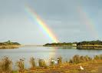](http://www.google.com.au/imgres?imgurl=http://www.surfangle.com/images/anglesea%20rivermouth,%20rainbow.jpg&imgrefurl=http://www.surfangle.com/images/&usg=__z68hpt9azSz5JRmNlDQdgGJWb0k=&h=400&w=560&sz=201&hl=en&start=112&zoom=1&um=1&itbs=1&tbnid=3-mTdcUmmhwSpM:&tbnh=95&tbnw=133&prev=/images?q=surfing+anglesea&start=108&um=1&hl=en&sa=N&rlz=1R2DBAU_en&ndsp=18&tbs=isch:1)****Specialised Offsite Activities***

***Go Ride a Wave (GRAW)***

*Phone: 5263 2111 Anglesea Main Beach*

*Surfing, kayaking, swimming, surf carnival and more.*

[www.**gorideawave**.com.au/](http://www.gorideawave.com.au/)

***SeaEarth Adventures***

*Anglesea Main Beach*

*Surfing, kayaking, swimming, surf carnival and more.*

*Call Dane: 03 5261 2241*

[www.**seaearthadventures**.com.au](http://www.seaearthadventures.com.au)

***Eco Logic Environmental Services***

*Anglesea Main Beach or onsite*

*Phone: 5263 1133*

*Beach or bush – engaging and educational activities.*

[www.**ecologic**.net.au/](http://www.ecologic.net.au/)

***Great Ocean Road Adventure Tours (GORATS)***

*Anglesea based*

*Phone: Simon 0417 576 973*

*Mountain bike riding and canoeing adventures.*

**gorats.com.au**/

***Parks Victoria***

*Phone: 5263 3144 Anglesea Office*

***Narana Creations***

*Phone: 5241 5700*

*410 Torquay Rd Geelong VIC 3216*

*Email:* [*narana@narana.com.au*](mailto:narana@narana.com.au)

*Aboriginal Craft & Cultural Interpretation Centre*

***National Wool Museum***

*Phone: 5261 0701 Geelong*

*Excellent educational resource*

[www.geelongaustralia.com.au/nwm/](http://www.geelongaustralia.com.au/nwm/)

***Surfworld Museum***

*Phone: 5261 4606 Torquay*

*Terrific for Upper Primary groups and above*

[www.**surfworld**.com.au/](http://www.surfworld.com.au/)

***Marine Discovery Centre***

*Phone: 5258 3344 Queenscliff*

*Stimulating marine education programs for all ages*

[www.**marinediscoverycentre**.com.au/](http://www.marinediscoverycentre.com.au/)