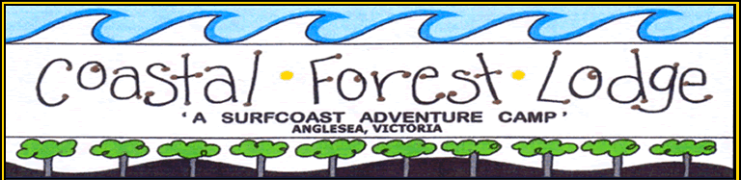

***General Information***

***for Teachers / Leaders***

[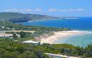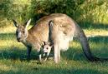](mailto:info@coastalforestlodge.com.au)

**Corner Forest and Gundrys Roads**

**BELLBRAE VIC 3228**

**Phone: 0421 049 754**

**Email:** [**info@coastalforestlodge.com.au**](mailto:info@coastalforestlodge.com.au)

**Website:** [**www.coastalforestlodge.com.au**](http://www.coastalforestlodge.com.au)

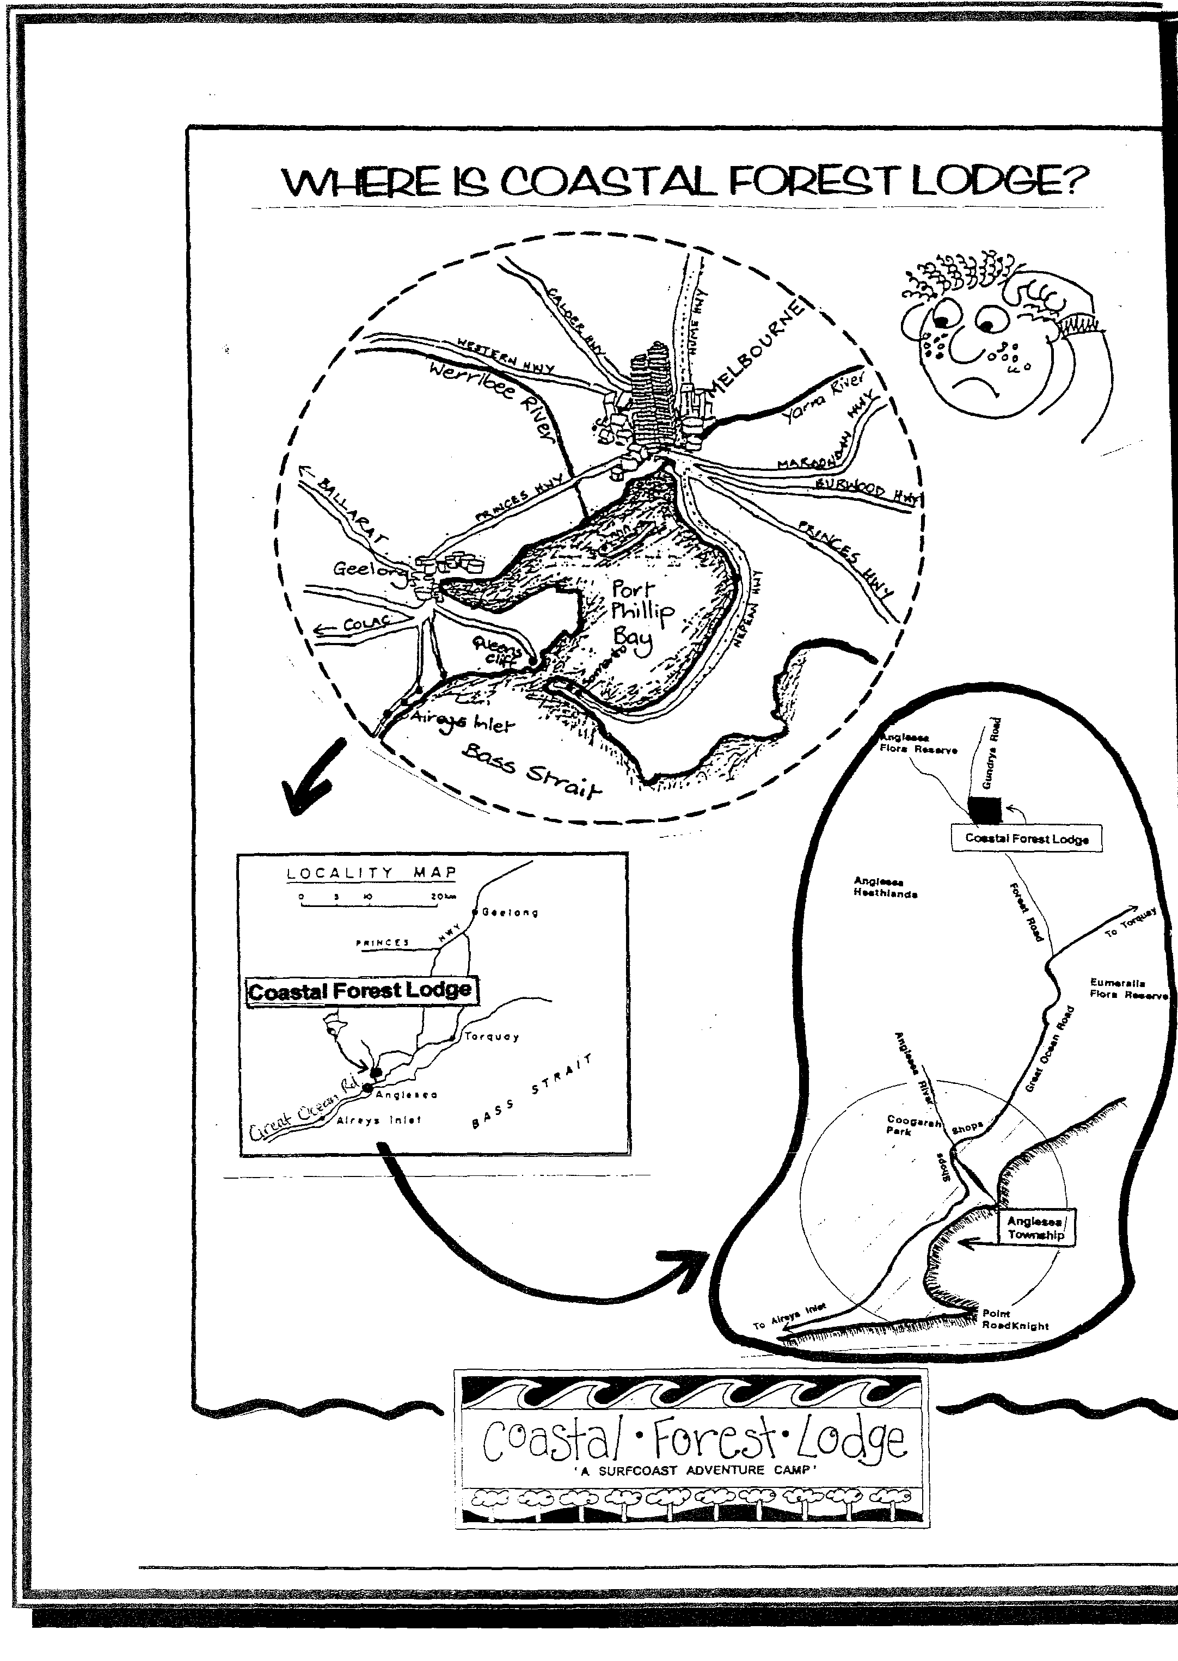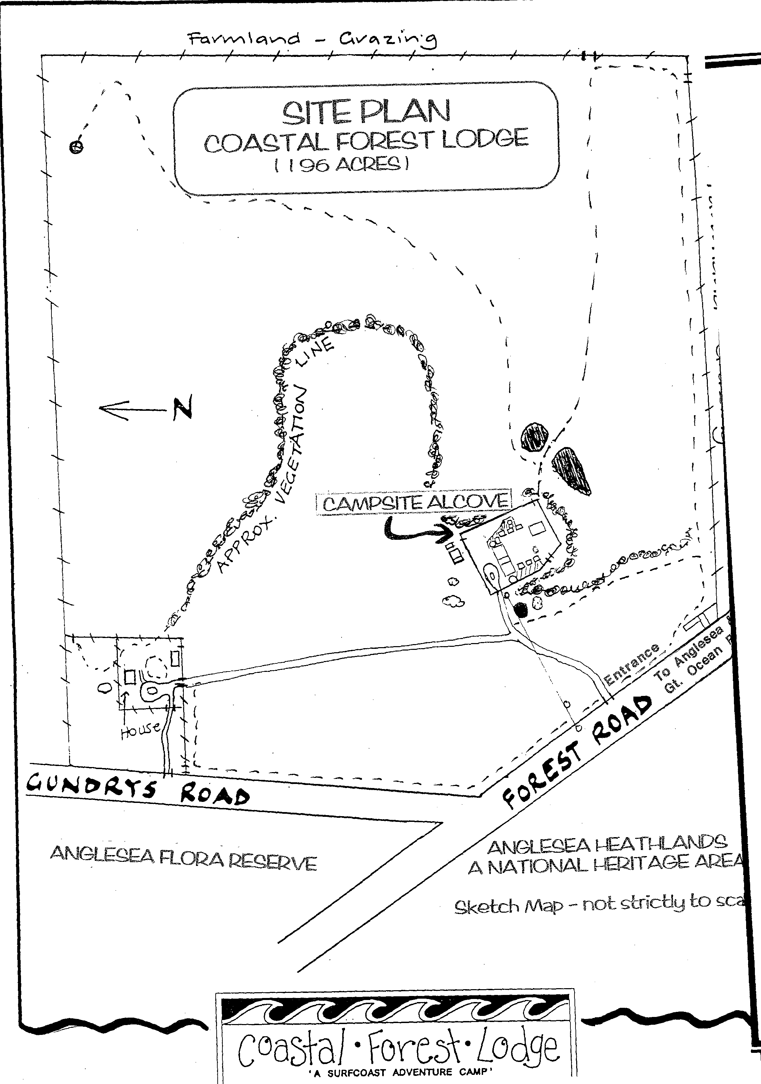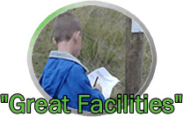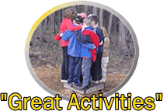

***General Information***

***\*Current Government COVID19 restrictions and procedures must always be followed.***

***\*CFL COVIDSafe Plan must always be followed.***

***\*DO NOT ATTEND CFL IF YOU HAVE BEEN UNWELL, TRAVELLED OVERSEAS OR BEEN IN CONTACT WITH A POTENTIALLY INFECTED PERSON WITHIN THE LAST 14 DAYS.***

***\* DO NOT ATTEND CFL IF YOU HAVE A HIGH TEMPERATURE.***

***\* WEAR APPROPRIATE PPE AND SOCIAL DISTANCE WHEN REQUIRED.***

***\* DO NOT SHARE PERSONAL ITEMS.***

***\* WIPE ALL SURFACES WITH DISINFECTANT AFTER USE.***

***\* WASH HANDS REGULARLY WITH ANTIBACTERIAL SOAP AND WARM WATER.***

**Arrival**

On arrival at Camp, the leader will do a check of facilities and have a briefing with the Camp Manager / designated staff member in charge.

Please note that group members arriving before their group’s leader will not be permitted to move into the facility until the above check and briefing have been completed.

**Accommodation**

Cabins will be made available to the group according to the size and needs of the group.

**Camper Briefing**

Staff will conduct a briefing for school groups.

For self-cater groups it is expected that the group leader will brief their group re: safety, camp rules and emergency procedures as soon as practical after arrival.

**Car Parking**

Please only park in designated areas.

**Camp Rules**

For a happy, enjoyable and safe stay, camp rules must be followed. These are listed in this booklet and around the campsite. It is expected that the group leader will ensure that all campers are aware of these rules and that they abide by them.

**First Aid – GROUPS MUST BYO FIRST AID KITS AND TRAINED PERSONNEL AS REQUIRED.**

First aid needs (including a trained / qualified person) are the responsibility of the group. It is recommended that groups bring First Aid kits which are sufficient for the needs of their group and relevant to the activities being undertaken. Please bring portable kits for offsite activities too. At least one car must be available for emergency use.

**Campers**

The Group Leader must complete a “list of campers” form including all leaders, / adults / children etc. (Health Reg S.R.# 81/1990 Pt 5). This sheet will be given to the group leader upon arrival. School groups are only to provide student numbers.

**Emergency Plans**

These are on display in the Meeting Room and include emergency numbers and locations. The group leader will be provided with further information and is requested to become familiar with the campsite’s emergency procedures.

**Medical Information**

See emergency plan for phone numbers. Medical facilities are located in Anglesea (5mins drive), Torquay (15mins drive) and major hospital facilities in Geelong (approx 30 mins drive). An ambulance service is available in Anglesea.

**Visitors**

Please inform the Camp Manager if visitors are expected or if they arrive unexpectedly. A charge applies to visitors who use the camp facilities and / or stay overnight.

**Phone**

At least one group member is required to have access to a mobile phone at all times.

**Mail**

Mail can be posted at the Anglesea Post Office. It is cleared each week at 5pm. Camp staff are happy to assist by posting mail for you.

**Laundry**

The washing machine and dryer are only available for emergency use due to the limited water supply at CFL. Please see camp staff if use is required

**Local Shops**

Anglesea and Torquay have shopping centers comprising of supermarkets, banks, chemist, butchers, newsagent, post office, take away food, ect.

**Transport**

Groups using Coastal Forest Lodge generally organize their own transport needs. For a competitive quote try Australian Coach Travel on 9555 0166 or Peninsula Bus Lines on 9786 7088. Around Geelong and district try Anglesea Travel / Coles Coaches on 5243 8772 (Gavin Lugg). Groups wanting to hire a mini bus could try Reilly’s U Drive in Geelong on 5272 3222.

**Departure**

A check of facilities will be carried out by CFL staff prior to the group’s departure**. *Groups must vacate and clean cabins BY 9.30AM on the day of departure***. Clean up details are outlined later in this booklet, but it is expected that facilitates / grounds will be left in the same clean condition as found. The group may then continue to use activities / premises on the final day until departure time.

**Bond**

The bond will be returned as per Booking Form/Hire Agreement.

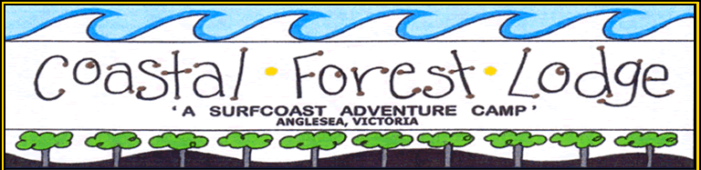

***[](http://www.google.com.au/imgres?imgurl=http://www.stoplooksign.com/images/look.gif&imgrefurl=http://www.stoplooksign.com/&h=155&w=155&sz=4&tbnid=NTS7Bh8irrk-qM:&tbnh=97&tbnw=97&prev=/images%3Fq%3Dlook%2Bsign&zoom=1&hl=en&usg=__OWZT0q2N9qaeqsxDPd3Z6xQin94=&sa=X&ei=oIRwTOefK8KwcdLqqMcN&ved=0CBwQ9QEwAg)Camp Rules [](http://www.google.com.au/imgres?imgurl=http://www.stoplooksign.com/images/look.gif&imgrefurl=http://www.stoplooksign.com/&h=155&w=155&sz=4&tbnid=NTS7Bh8irrk-qM:&tbnh=97&tbnw=97&prev=/images%3Fq%3Dlook%2Bsign&zoom=1&hl=en&usg=__OWZT0q2N9qaeqsxDPd3Z6xQin94=&sa=X&ei=oIRwTOefK8KwcdLqqMcN&ved=0CBwQ9QEwAg)***

***Your assistance with these rules is most appreciated***

***CAMPS MUST OPERATE INLINE WITH GOVERNMENT COVID DIRECTIVES AND SAFETY RULES. GUESTS MUST FOLLOW COVIDSAFE PROCEDURES AS DIRECTED BY THE CAMP AND THE GOVERNMENT.***

**Cabins**

* Food and drinks must not be consumed in the cabins / bedrooms at any time.
* **All campers must bring their own pillow, pillowcase and SUPER WARM sleeping bag**!
* **Bring hand sanitizer, PEE / face mask if required, tissues, individual toiletries**.
* **PLEASE BRING SUPER WARM SLEEPING BAG AND CLOTHING!!! i.e. thermals, beanies, slippers, down jackets, etc. Please note: the cabins are not heated, and guests must come well prepared with super warm sleeping gear. All common areas are well heated, thank you.**
* Camp mattresses must not be removed from the cabins.
* Campers are not to swap rooms without adult permission.
* Only one-person 9yrs> is permitted on a top bunk at a time.
* Please use small amounts of toilet paper to avoid any blockage and only toilet paper!

**\*STRICTLY NO PLAYING IN CABINS\***

**Smoking**

Smoking is **not** permitted inside any camp building.

**Campfire / Bush Cooking Area**

These are the only places where fires are permitted and only in accordance with local fire season restrictions. Please check with the Camp Manager. Wood for the campfire should be collected from around the bush areas of the camp.

**Recreation, Games and Dining Rooms**

Students / Campers must be **supervised at all times** by a teacher / leader / adult when using these rooms and equipment.

**Ball Games**

These games must not be played on deck areas, verandahs or in the camp alcove. Please use the large area beyond the cabins, next to and around the basketball court. They must be conducted on the far side of the white posts.

**Damage**

Any breakages / damage must be reported to the Camp Manager when it occurs.

**Care of the Environment**

Campers are asked to stay on tracks, use rubbish bins and respect our resident kangaroos, bird life, reptiles and vegetation.

**Camp Boundaries**

Campers must stay within the fenced alcove at all times unless accompanied by a teacher / leader during activity sessions. All signed service areas are out of bounds.

**Pets / Firearms** [](http://www.google.com.au/imgres?imgurl=http://www.stoplooksign.com/images/look.gif&imgrefurl=http://www.stoplooksign.com/&h=155&w=155&sz=4&tbnid=NTS7Bh8irrk-qM:&tbnh=97&tbnw=97&prev=/images%3Fq%3Dlook%2Bsign&zoom=1&hl=en&usg=__OWZT0q2N9qaeqsxDPd3Z6xQin94=&sa=X&ei=oIRwTOefK8KwcdLqqMcN&ved=0CBwQ9QEwAg)

We do not allow pets or firearms on our property.

**Wet Weather**

Gumboots / dirty footwear must not be worn in the camp buildings.

No shoes are to be worn inside at anytime.

**Fire Equipment**

Extinguishers, signs and smoke detectors are installed for your protection – please make sure that campers do not interfere with this important safety equipment.

**Water Supply**

Our only water supply is tank water. Please help us to conserve these supplies by not wasting water and by limiting shower time. Keep check to make sure taps are turned off and let us know if there are any problems.

Helpful Hints: - Short showers

* Use ½ flush
* No dripping taps
* Inform manager immediately of any problems occur

**Verandahs**

No Running and please do not climb on the handrails. Keep clean and swept.

***\*PLEASE USE RUBBISH BINS\****

***Please do not:***

* Play in out of bounds areas i.e. garden beds.
* Touch fly screens ask a teacher / CFL staff if need be!
* Throw stones.
* Bush bash, break trees or throw things into the dams.
* Touch electrical or maintenance equipment. This is locked anyway. Stay away.

***THANK YOU & HAVE A FUN & FANTASTIC CAMP!***



***\*Current Government COVID restrictions and procedures must always be followed.***

***\*The CFL COVIDSafe Plan must always be followed.***

***\*DO NOT ATTEND CFL IF YOU HAVE BEEN UNWELL, TRAVELLED OVERSEAS OR BEEN IN CONTACT WITH A POTENTIALLY INFECTED PERSON WITHIN THE LAST 14 DAYS.***

***\* DO NOT ATTEND CFL IF YOU HAVE A HIGH TEMPERATURE.***

***\* WEAR APPROPRIATE PPE AND SOCIAL DISTANCE AS REQUIRED.***

***\* DO NOT SHARE PERSONAL ITEMS.***

***\* WIPE ALL SURFACES WITH DISINFECTANT AFTER USE.***

***\*WASH HANDS REGULARLY WITH ANTIBACTERIAL SOAP AND WARM WATER.***

***Please Note: CFL does not accept any responsibility for loss or damage to personal items such as mobile phones, MP3 player / iPods, digital cameras, ect. It is strongly recommended that campers do NOT bring these items with them.***

**[](http://www.google.com.au/imgres?imgurl=http://www.food-faq.net/food/healthy-foods.jpg&imgrefurl=http://www.food-faq.net/&usg=__nQTPQ0Tn-QCGLlbFThsyaWTCdN4=&h=319&w=570&sz=33&hl=en&start=4&zoom=1&um=1&itbs=1&tbnid=JskcdGQtTVcSxM:&tbnh=75&tbnw=134&prev=/images%3Fq%3Dhealthy%2Bfood%26um%3D1%26hl%3Den%26rlz%3D1R2DBAU_en%26tbs%3Disch:1)** ***Catering [](http://www.google.com.au/imgres?imgurl=http://www.crossfitenergy.com/wp-content/uploads/2009/04/quality2.jpg&imgrefurl=http://www.crossfitenergy.com/diet-and-nutrition&usg=__xsuI8EGH8B7_j7pPOyRPR0nZRao=&h=252&w=350&sz=32&hl=en&start=36&zoom=1&um=1&itbs=1&tbnid=y0XJchEDLfo_zM:&tbnh=86&tbnw=120&prev=/images%3Fq%3Dquality%2Bfood%26start%3D18%26um%3D1%26hl%3Den%26sa%3DN%26rlz%3D1R2DBAU_en%26ndsp%3D18%26tbs%3Disch:1)***

**Meal Times: Breakfast - 8am**

**Lunch - 12.00pm**

**Dinner - 5.45pm**

We can usually vary these times to suit your program if prior notice is given (before the camp commences). Picnics are also available by arrangement. Using a bush cookout as part of a lunch is only available by prior arrangement and is subject to strict controls (fire / seasonal conditions).

We also try to plan each group’s menu to suit their activity program, so it is helpful if you could provide an outline of your proposed program, at least a week prior to the camp. A variety of well balanced and nutritional meals will be provided.

Complimentary morning and afternoon teas are provided, both onsite and offsite.

***Supper is NOT offered as part of catering.***

***Meal Duty Groups:***

Teachers are to roster a group of students to assist with setting tables, serving & cleaning up. Generally, these are the same groups used for onsite camp activity rotations or cabin groups i.e. approx 8 - 12 students per group. It is required that the same duty group complete setting up and cleaning up tasks for a whole meal.

***A teacher/ leader must accompany each duty group, until the group is finished***. Duty group reports to dining room ***30 minutes before******(lunch is 5mins before)*** the meal commences.

***\*PLEASE ASK CAMP STAFF ANY QUESTIONS AT ANYTIME DURING YOUR STAY\****

***Cleaning***

***During your stay, CFL is your “home” so please look after it!***

***GUESTS MUST FOLLOW THE COVIDSAFE RULES***

**Each Day:**

* Cabins / bedrooms tidied – brooms, dustpan and brush are available in each cabin for student use.
* Wet towels should be hung outside to dry.
* Shoes / gumboots are NOT to be worn inside at ANYTIME in any building – they are to be left outside on the undercover verandahs.
* Rec. room, games, meeting room should be tidied and swept.
* Bathrooms should be tidied and swept.
* Verandahs should be tidied and swept.
* Any damages, leakages, or repairs should be reported to management immediately.
* Spray and wipe surfaces.

**Departure Day:**

Please make sure the following tasks have been completed. A check will then be carried out by the Camp Manager / Camp Staff. It is required that each group packs up and cleans up cabins **AFTER BREAKFAST** on the day of departure **BY 9.30AM**. For speedy and hassle free clean up teachers / leaders need to encourage and supervise the students. Other facilities / activities can still be used as required once rooms have been vacated and left accordingly.

* Cabins / Bedrooms – tidied, swept, mattresses standing on bunk.

***Please inform the Camp Manager of any soiled bedding.***

* Bathrooms - Tidied (clean up all litter including soap, ect.) and swept.
* *The sanitizing will be completed by Camp Staff.*
* Dining Room - Tidied and swept.
* Meeting Room - Tidied and swept.
* Games Room - Tidied and swept.
* Main Verandah - Tidied and swept.
* Emu Parade - Clean up of all litter around the campsite.
* Equipment - Check all camp equipment used – number and condition.**[http://www.google.com.au/images?q=tbn:orvdyET92avjJM::www.redlorry.co.za/Portals/8/xin_4908032223207983059534.jpg&h=78&w=63&usg=__CLG5L_oV19epXLlYyTb3ZAVbTJ8=](http://www.google.com.au/imgres?imgurl=http://www.redlorry.co.za/Portals/8/xin_4908032223207983059534.jpg&imgrefurl=http://www.redlorry.co.za/atlas/media/2000-sydney-olympics.aspx&h=367&w=300&sz=14&tbnid=orvdyET92avjJM:&tbnh=122&tbnw=100&prev=/images%3Fq%3Dsydney%2Bolympics&zoom=1&hl=en&usg=__hYYGQ4Dk7dZG9Zz7YYSYOyN_Pwk=&sa=X&ei=pJBwTLiMOtCPcbXs-KgN&ved=0CDoQ9QEwBw)** ***Accommodation – Proposed Sleeping Plan [http://www.google.com.au/images?q=tbn:orvdyET92avjJM::www.redlorry.co.za/Portals/8/xin_4908032223207983059534.jpg&h=78&w=63&usg=__CLG5L_oV19epXLlYyTb3ZAVbTJ8=](http://www.google.com.au/imgres?imgurl=http://www.redlorry.co.za/Portals/8/xin_4908032223207983059534.jpg&imgrefurl=http://www.redlorry.co.za/atlas/media/2000-sydney-olympics.aspx&h=367&w=300&sz=14&tbnid=orvdyET92avjJM:&tbnh=122&tbnw=100&prev=/images%3Fq%3Dsydney%2Bolympics&zoom=1&hl=en&usg=__hYYGQ4Dk7dZG9Zz7YYSYOyN_Pwk=&sa=X&ei=pJBwTLiMOtCPcbXs-KgN&ved=0CDoQ9QEwBw)***

***Maximum 2 teachers per room. (Adults – social distancing applies).***

|  |  |  |
| --- | --- | --- |
| SYDNEY  *Shared ensuite between two rooms.* | Room 1 | 2 bottom bunk beds  2 top bunk beds |
| Room 2 | 2 bottom bunk beds  2 top bunk beds |
| ATLANTA  *Shared ensuite between two rooms.* | Room 3 | 2 bottom bunk beds  2 top bunk beds  1 single bed |
| Room 4 | 2 bottom bunk beds  2 top bunk beds  1 trundle bed |
| BARCELONA  ***\*\*Teachers\*\****  ***ENSUITE PER ROOM*** | Room 5 | 2 bottom bunk beds  2 top bunk beds  **PER ROOM, WITH ENSUITE PER ROOM** |
| Room 6 |
| SEOUL  *Shared ensuite between two rooms.* | Room 7 | 2 bottom bunk beds  2 top bunk beds  1 trundle bed |
| Room 8 | 2 bottom bunk beds  2 top bunk beds  1 trundle bed |
| LOS ANGELES  *Shared ensuite between two rooms.* | Room 9 | 2 bottom bunk beds  2 top bunk beds  1 trundle bed |
| Room 10 | 2 bottom bunk beds  2 top bunk beds  1 trundle bed |
| MOSCOW  *Shared ensuite between two rooms.* | Room 11 | 2 bottom bunk beds  2 top bunk beds  1 single bed |
| Room 12 | 2 bottom bunk beds  2 top bunk beds  1 trundle bed |
| MONTREAL  ***\*\*Teachers\*\****  ***ENSUITE PER ROOM*** | Room 13 | 2 bottom bunk beds  2 top bunk beds  **PER ROOM, WITH ENSUITE PER ROOM** |
| Room 14 |
| MUNICH  *Shared ensuite between two rooms.* | Room 15 | 2 bottom bunk beds  2 top bunk beds  1 single bed |
| Room 16 | 2 bottom bunk beds  2 top bunk beds  1 single bed |
| ROOM 17 |  | 3 top bunks  3 bottom bunks  2 trundles if required |
| ROOM 18  *NO ENSUITE OR SHOWER (Communal Toilet & sink nearby).* |  | 2 bottom bunk beds  2 top bunk beds |
| ROOM 19 |  | 2 top bunks  2 bottom bunks  1 single bed |

**Maximum Total: Students: 75 Teachers: 8**

***\*Please send a completed copy to the manager at info@coastalforestlodge.com.au before arrival. A copy of the sleeping plan including attendees’ full names must be provided before arrival. Thank you!***

***Example of cabin layout***

*Please note staff cabins do not have a shared bathroom. Staff cabins have their own bathroom per room.*

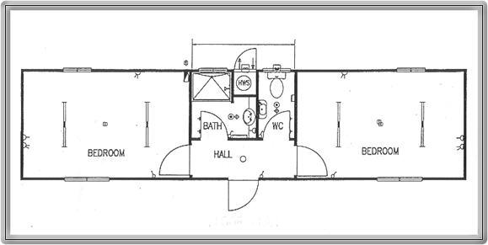

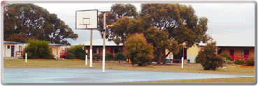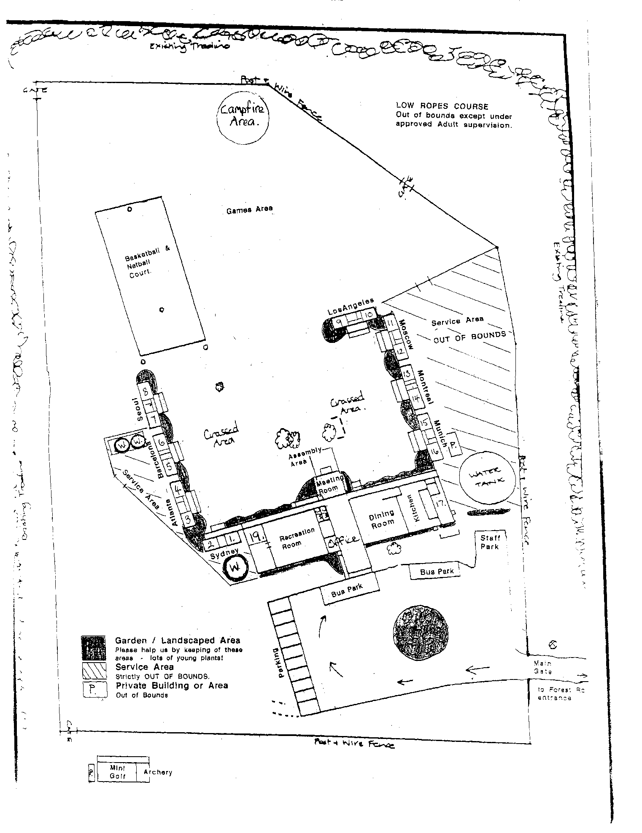**[](http://www.google.com.au/imgres?imgurl=http://www.stoplooksign.com/images/look.gif&imgrefurl=http://www.stoplooksign.com/&h=155&w=155&sz=4&tbnid=NTS7Bh8irrk-qM:&tbnh=97&tbnw=97&prev=/images%3Fq%3Dlook%2Bsign&zoom=1&hl=en&usg=__OWZT0q2N9qaeqsxDPd3Z6xQin94=&sa=X&ei=oIRwTOefK8KwcdLqqMcN&ved=0CBwQ9QEwAg)*EMERGENCY PHONE NUMBERS***

**DIAL 000**

**Fire, Police, Ambulance and S.E.S**

***At least one teacher / leader must have access to a MOBILE phone at ALL TIMES.***

**Doctor: Anglesea: 4215 6700**

**63 Great Ocean Rd, Anglesea VIC 3230**

**Torquay: 4215 7900**

**Health Centre, 100 Surf Coast Hwy, Torquay VIC 3228**

**Hospital: Geelong: 4215 0000**

**Geelong Hospital, Bellerine St, Geelong, VIC 3220**

**Chemist: Anglesea: 5263 1540**

**Dentist: Torquay: 5261 2240**

**POISON INFORMATION: 13 11 26**

**Location Description:**

“Coastal Forest Lodge”

**Corner Forest and Gundrys Roads, BELLBRAE VIC 3228.**

*Entrance: Forest Road - 2kms from the Great Ocean Road roundabout.*

***BLUE FLAGS OUT THE FRONT!!***

Not shown in Melways: Country Vic Melway Map 296 G1

***Specialised Activity Ideas & Places of Interest***

***Eco Logic Environmental Services***

*Phone: 5263 1133 Anglesea Based*

*Beach or bush – engaging and educational activities.*

*[http://t1.gstatic.com/images?q=tbn:ZRGdfzvMs9txeM:http://www.voea.vic.edu.au/memberdirectory/ecologic.jpg](http://www.google.com.au/imgres?imgurl=http://www.voea.vic.edu.au/memberdirectory/ecologic.jpg&imgrefurl=http://www.voea.vic.edu.au/memberdirectory/index.html&usg=__rKY35qhcc3AxhafZHlu7KCRTXpo=&h=92&w=557&sz=16&hl=en&start=18&zoom=1&um=1&itbs=1&tbnid=ZRGdfzvMs9txeM:&tbnh=22&tbnw=133&prev=/images%3Fq%3Decologic%2Banglesea%26um%3D1%26hl%3Den%26rlz%3D1R2DBAU_en%26tbs%3Disch:1)*

***Great Ocean Road Adventure Tours***

*Phone: 5289 6841 Aireys Inlet based*

*Mountain bike riding and canoeing adventures.*

*[](http://www.gorats.com.au/)*

***Go Ride a Wave***

*Phone: 5263 2111 Anglesea based*

*Surfing, ocean kayaking, swimming, surf rescue and more.*

*[](http://www.google.com.au/imgres?imgurl=http://www.wickedfriends.com.au/%3Ftdomf_download%3D262%26id%3D0&imgrefurl=http://www.wickedfriends.com.au/tag/vic/&usg=__fE3x_YVm0dnPOaqUDzgIFldwT4Q=&h=912&w=1830&sz=74&hl=en&start=79&zoom=1&um=1&itbs=1&tbnid=ZxsKFZYDAKD6rM:&tbnh=75&tbnw=150&prev=/images%3Fq%3Dsurfing%2Banglesea%26start%3D72%26um%3D1%26hl%3Den%26sa%3DN%26rlz%3D1R2DBAU_en%26ndsp%3D18%26tbs%3Disch:1)*

***Parks Victoria***

*Phone: 5263 3144 Anglesea Office*

***SeaEarth Adventures***

*Phone: 5261 2241 Torquay & Anglesea*

*venues for surfing.*

***National Wool Museum***

*Phone: 5261 0701 Geelong*

*Excellent educational resource.*

***Surfworld Museum***

*Phone: 5261 4606 Torquay*

*Terrific for Upper Primary groups and above.*

**

***Marine Discovery Centre***

*Phone: 5258 3344 Queenscliff*

*Stimulating marine education programs for all ages.*

**

***Narana Creations***

*Phone: 5241 5700*

*410 Torquay Rd Geelong VIC 3216*

*Email:* [*narana@narana.com.au*](mailto:narana@narana.com.au)

*Aborignal Craft & Cultural Interpretation Centre*

**[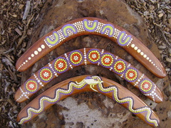](http://www.narana.com.au/products/17-returning-boomerang)*Teachers’ Information***

*These are laminated resource pages kept in the staff room.*

* ***Emergency Management Plan***
* Camp and Area Maps

**Activity procedures (all materials and equipment are provided by CFL):**

* **Initiative Activities** – what they are and how to use them.
* **Archery** – correct shooting technique and safety briefing.
* **Low Ropes Course** – spotters, safety briefing and layout.
* **Orienteering** – answer sheets for all courses.
* **Photo Trail** – answer sheet.
* **Eagles Nest Walk** – map and guide.
* **Boundary Rider Walk (Night Walk)** – map and guide.
* **Mini Golf** – rules and safety briefing.
* **Bush Shelter Building** – map, rules and safety breifing.

***FURTHER ASSISTANCE FROM MANAGER OR STAFF IS ALWAYS AVAILABLE, PLEASE ASK!***

***Important info for your bus driver:***

***\*\*The camp entrance is on Forest Rd (NOT GUNDRYS RD****) \*\**

*GO PAST the Gundrys Rd turnoff and Great Ocean Rd chocolaterie until you reach the roundabout at Forest Rd, then turn right. The camp entrance is 2km on the right with blue flags out front.*

**\*\*DO NOT TURN DOWN GUNDRYS RD\*\***

Once inside the camp gates simply follow the gravel road to a large central turning area and pull-up in front of the arrivals area.

***Teachers Checklist***

**PLEASE CONTACT US AT LEAST ONE WEEK BEFORE CAMP TO CONFIRM:**

**1.** Number of students and staff attending.

**2.** Arrival time.

**3.** Itinerary.

**4.** Special dietary requirements – serious allergies, religious

Grounds, etc.

**5**. Proposed Sleeping Plan.

**6. BYO FIRST AID KITS, ASTHMA KITS, EPIPENS & FIRST AIDERS.**

**HAND SANITIZER, PPE, masks, tissues, etc.**

**7.** BYO one staff vehicle.

**8.** Extra visitors for meals or program assistance.

**9. BYO super warm bedding including pillows. The cabins are not**

**heated. Please bring super warm bedding and clothing!!**

**All common areas are well heated.**

***Remember to Bring***

* **First Aid Kits, asthma kits, EpiPen’s, HAND SANITIZER, PPE (include a portable kit to suit activities), trained first aiders, etc. This is the school’s responsibility.**
* Completed medical forms for each camper.
* A **staff vehicle** is essential for use in an emergency and to comply with ‘duty of care’ requirements.
* Additional sports gear as needed- basketball, volleyball, football, bat tennis, netball, etc.
* Portable music device if required.
* DVDs if required (TV, DVD player, amplifier, projector, and screen are available).
* Art / Craft materials if needed.
* Indoor games and board games.
* **Wet weather activities (just in case).**
* Whistles for staff.
* Covered shoes! Shoes for water activities! Spare shoes!!
* **Sunscreen, hat and water bottle.**
* Concert / Disco gear (dress ups, props, music).
* Bit and Pieces (Blu-tack, stapler, whiteboard markers, pins, etc.)

***What Students Should Bring***

***The following is a suggested list only.***

***Please consider the time of year, the length of your camp and the activities in which you will be participating.***

***PLEASE BRING SUPER WARM BEDDING AND CLOTHING, THE CABINS ARE NOT HEATED!***

**SUPER warm BYO Pillow** thermals & slippers

**sleeping bag**

**WATER BOTTLE HAT** WARM jacket

Bath towel **Walking shoes & socks** Toiletries

Extra shoes (for water activities) **SUPER WARM JUMPER**

Warm pajamas Soap & shampoo Gumboots

**Waterproof jacket** Toothbrush Beanie

Shorts Hairbrush

Bathers & beach towel Garbage bag **Sunscreen SPF 30+** Pencil case

Jeans / track pants Ruler

Shirts / T-Shirts  Writing pad

Underwear  Pens

**Plenty of socks!!**  Books

Very warm jumpers **Torch**

Hand Sanitizer Camera (optional)

***\*All the above items should be clearly labeled with student’s name\****

***NOTES:***

* Usually on school camps students need at least one change of clothes for each day (don’t forget a bag for dirty/worn clothes!).
* It is suggested that students bring only one case or bag, a **SUPER WARM sleeping bag, pillow & pillowcase** and a backpack.
* Teachers / leaders please notify the camp manager regarding any bed wetter’s or sleepwalkers.
* A **“shoe’s off”** policy is in place throughout all buildings. It’s suggested that campers bring ***slippers or thick socks to ear inside and keep warm!***
* **BYO Drink bottles** – Compulsory.